Basics of Structural Geology
First of all we need to understand how rocks deform?
MODES OF DEFORMATION OF ROCKS
- Within the Earth, rocks are continually being subjected to forces that tend to bend them, twist them, or fracture them.
- When rocks bend, twist or fracture we say that they deform (change shape or size).
- The forces that cause deformation of rock are referred to as stresses (Force/unit area). So, to understand rock deformation we must first explore these forces or stresses.
Stress and Strain
- Stress is a force applied over an area. One type of stress that we are all used to is a uniform stress, called pressure.
- A uniform stress is a stress wherein the forces act equally from all directions. In the Earth the pressure due to the weight of overlying rocks is a uniform stress, and is sometimes referred to as confining stress.
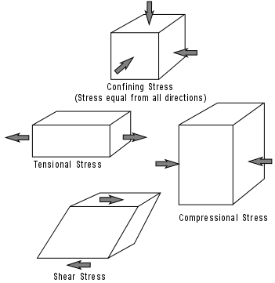
- When rocks deform they are said to be in strain.
- A strain is a change in size, shape, or volume of a material.
Differential Stress
- If stress is not equal from all directions then we say that the stress is a differential stress. Three kinds of differential stress occur.

- Tensional stress (or extensional stress), which stretches rock;
- Compressional stress, which squeezes rock;
- Shear stress, which result in slippage and translation.
Stages of Deformation
- When a rock is subjected to increasing stress it passes through 3 successive stages of deformation.
- Elastic Deformation -- wherein the strain is reversible.
- Ductile Deformation -- wherein the strain is irreversible.
- Fracture - irreversible strain-- wherein the material breaks.
- We can divide materials into two classes that depend on their relative behavior under stress.
- Brittle materials have a small or large region of elastic behavior but only a small region of ductile behavior before they fracture.
- Ductile materials have a small region of elastic behavior and a large region of ductile behavior before they fracture.
